Write SQL commands for the following queries

1. 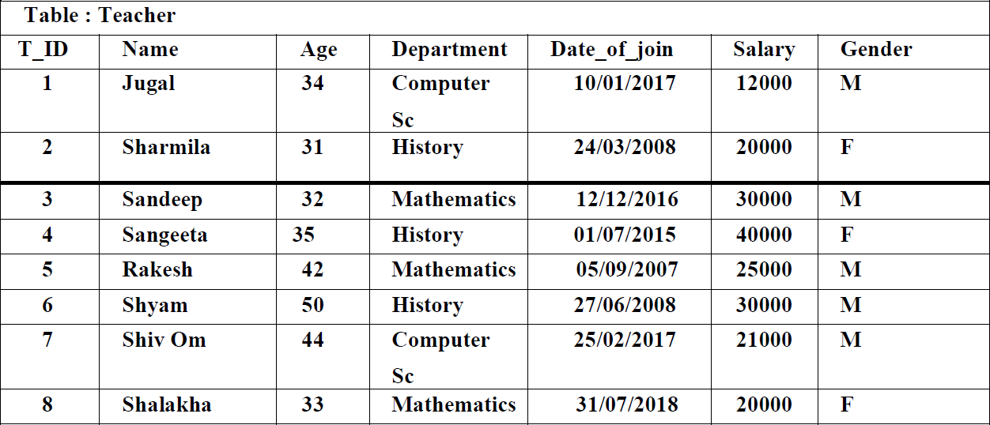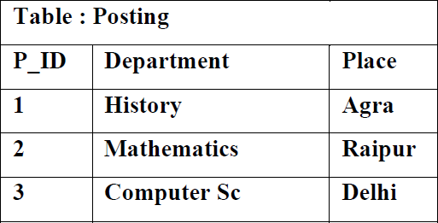**to (iv) based on the relations Teacher and Posting and output for (v) :**
   1. **To show all information about the teacher of History department.**
   2. **To list the names of all teachers with their date of joining in ascending order.**
   3. **To display teacher’s name, salary, age for male teachers only.**
   4. **Select max(Date_of_Join) FROM TEACHER where gender = ‘M’;**
   5. **To list the female teachers posted in Agra.**

QUERIES AND OUTPUT:

i.

SELECT * FROM TEACHER WHERE DEPARTMENT="HISTORY";

ii.

SELECT NAME FROM TEACHER ORDER BY DATE_OF_JOIN ASC;

iii.

SELECT NAME,SALARY,AGE FROM TEACHER WHERE GENDER="M";

iv.

+------------------------------+

| MAX(DATE_OF_JOIN) |

+------------------------------+

| 25/02/2017 |

+------------------------------+

1 row in set (0.00 sec)

v.

SELECT * FROM TEACHER T,POSTING P WHERE T.DEPARTMENT=P.DEPARTMENT AND GENDER="F" AND PLACE="AGRA";